Nguyễn Hoàng Huy

21138601

## Buổi 4: Docker

#### Phần 1:

|  |  |
| --- | --- |
| 1 | docker --version |
| 2 | docker run hello-world |
| 3 | docker pull nginx |
| 4 | docker images |
| 5 | docker run -d nginx |
| 6 | docker ps |
| 7 | docker ps -a |
| 8 | docker logs <container_id> |
| 9 | docker exec -it <container_id> /bin/sh |
| 10 | docker stop <container_id> |
| 11 | docker restart <container_id> |
| 12 | docker rm <container_id> |
| 13 | docker container prune |
| 14 | docker rmi <image_id> |
| 15 | docker image prune -a |
| 16 | docker run -d -p 8080:80 nginx |
| 17 | docker inspect <container_id> |
| 18 | docker run -d -v mydata:/data nginx |
| 19 | docker volume ls |
| 20 | docker volume prune |
| 21 | docker run -d --name my_nginx nginx |
| 22 | docker stats |
| 23 | docker network ls |
| 24 | docker network create my_network |
| 25 | docker run -d --network my_network --name my_container nginx |
| 26 | docker network connect my_network my_nginx |
| 27 | docker run -d -e MY_ENV=hello_world nginx |
| 28 | docker logs -f my_nginx |
| 29 | FROM nginx |
| COPY index.html /usr/share/nginx/html/index.html |
| 30 | docker build -t my_nginx_image . |
| 31 | docker run -d -p 8080:80 my_nginx_image |

#### Phần 2:

##### Bài 01:

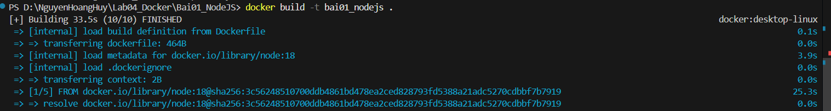

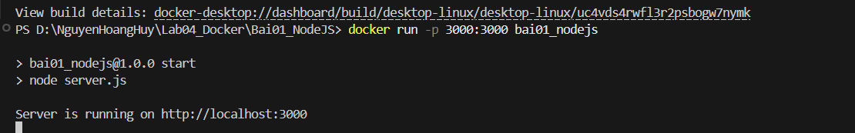

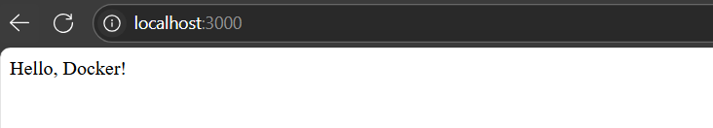

##### Bài 02:

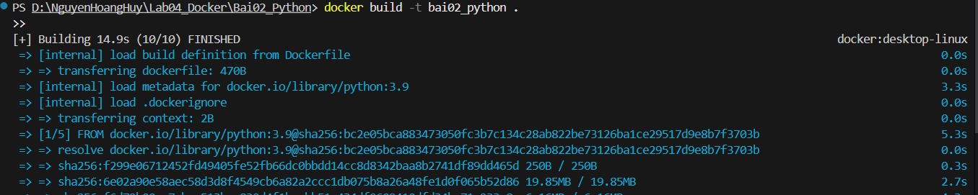

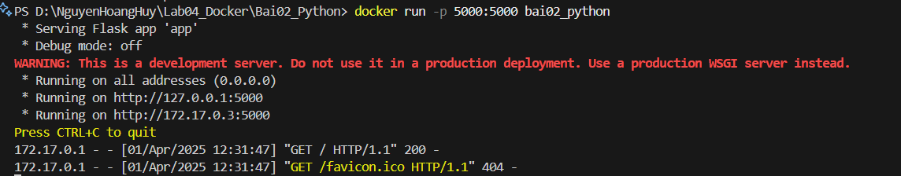

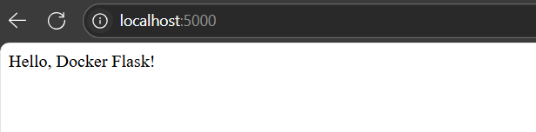

##### Bài 03:

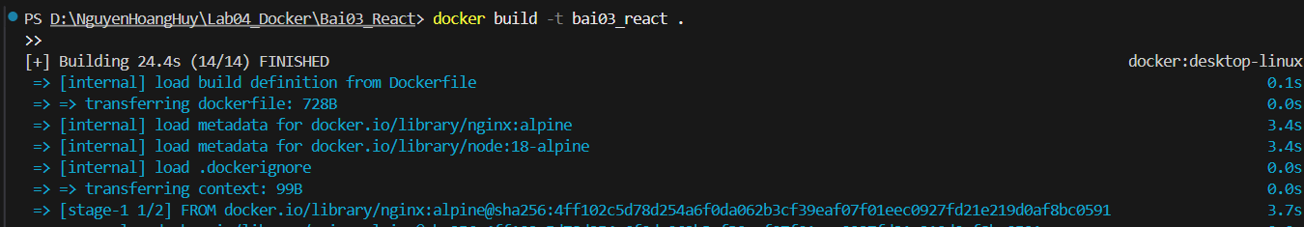

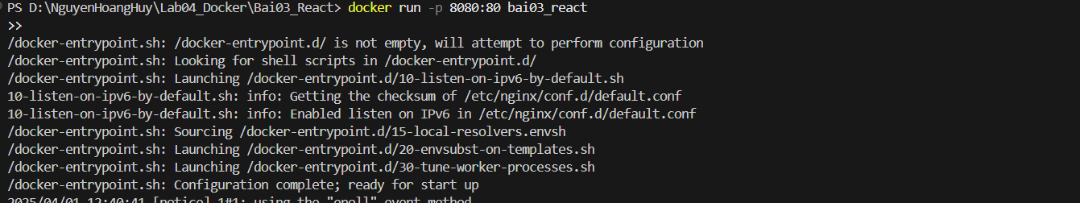

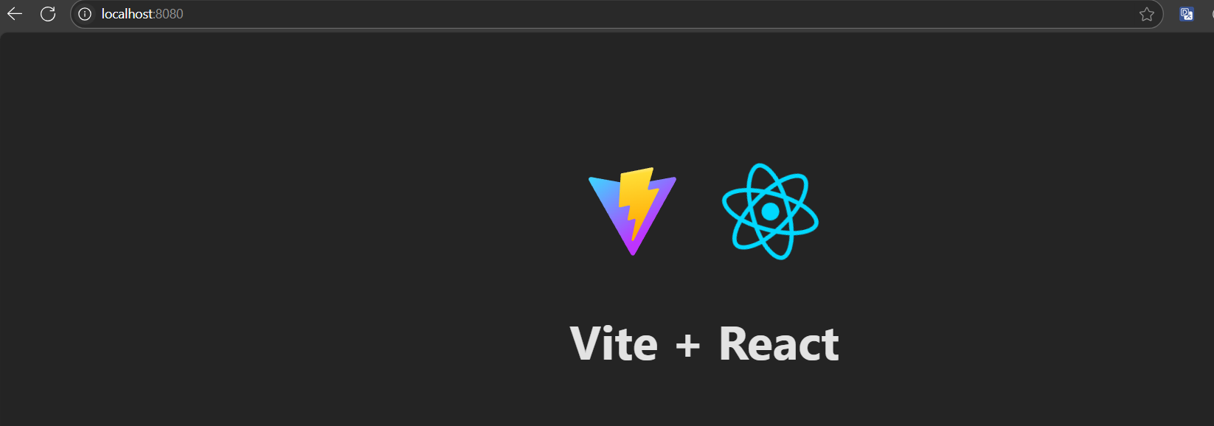

##### Bài 04:

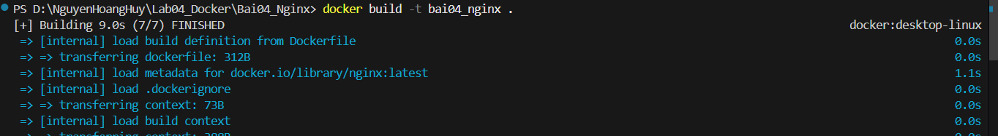

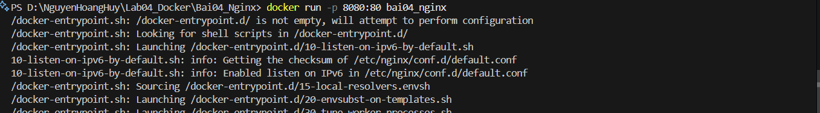

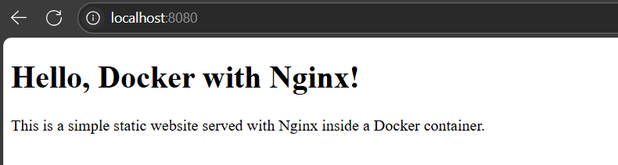

##### Bài 05:

